LEARNING TOOL OF PHOTOSHOP

1.MAGNETIC LASSO TOOL:

BEFORE:



AFTER:



2.PATCH TOOL

BEFORE:



AFTER:

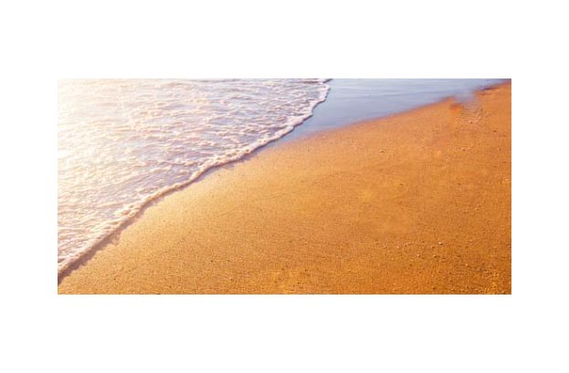

3.SMUDGE TOOL

BEFORE:



AFTER:



4.BLUR TOOL

BEFORE:

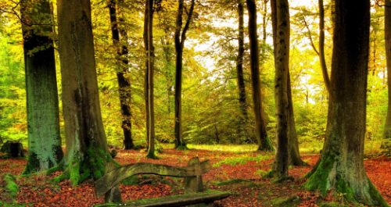

AFTER: